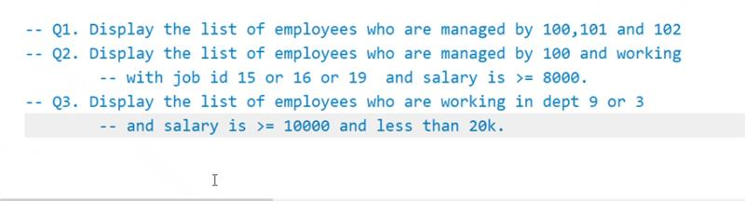

-- display the  emp name ,dept name and salary of steven.   
-- display the  emp name ,dept name and salary of employee working in dept 5 and 6.   
-- display the  emp name ,dept name and salary of employee working in Accounting dept.  
-- display the  emp name ,dept name and salary of employee working as Accountant.   
-- display the  emp name ,dept name and city working in seattle.

-- print the department id and min salary of departments only when their minimum salary is greater than 10000.

Display the department number, last name, and job ID for every employee in the Executive department.

use subquery

2. Display the last name and salary of every employee who reports to King.

3. display the employee numbers, last names, and salaries of all  
employees who earn more than the average salary

1. displays employee last names, salaries, department numbers, and average salaries for all the employees who earn more than the average salary in their department.

=========================================

Q1. Display the average salary of any perticular dept

Q2. Display the average salary of each dept starting from the deptid of first row of emp table

-- Q2 Display the employees who have atleast 1 person reporting to him.

-- find all departments that have employees.   
-- find all departments that do not have employees.

D13

Q1. create a MySQL stored procedure to update the salary of an employee entered by the user

CREATE DEFINER=`root`@`localhost` PROCEDURE `Updateemp`(in a int , b int )  
BEGIN  
update employees set salary=a  where employee_id=b;  
END

-- write a procedure to print the no of employee working   
-- and avg salary of a dept eneterd by the user  
-- (use 2 out type parameter)

CREATE DEFINER=`root`@`localhost` PROCEDURE `avgcount`(in x int,out c int,out d int)  
BEGIN  
select count(employee_id) ,avg(salary) into c, d  from employees where department_id=x ;  
END

 Write a plsql procedure to take the salary of a person as input

if the salary of the employee is greater than 10000 then update his salary with 30% increment

if the salary of the employee is greater than 5000  and 10000 then update his salary with 20% increment

if the salary of the employee is less than 5000  then update his salary with 10% increment

otherwise no change in salary